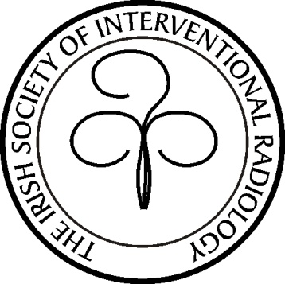

The Irish Society of Interventional Radiology

Autumn Meeting 2019

Herbert Park Hotel, Dublin, Ireland

Programme

Friday 8th of November 2019

17.00

Registration

Welcome
Tea/Coffee

17.00-19.00

Didactic Session

Dr. Peter Kavanagh- The Radiology Programme and IR

Endovascular simulator showcase

Dr Alan Smith - Best practice in mortality and morbidity conferences, registries and audit

19.00-20.00

Keynote Lecture, The history of embolization, from its inception to the present.

Dr. Karen Brown, Section Chief of Interventional Radiology, University of Utah School of Medicine, Department of Radiology & Imaging Sciences

20.00

Dinner

Herbert Park Hotel

Saturday 9th of November 2019

Clinical Session

09.00 – 11.00

Conference centre

Case Presentations & Complications in Interventional Radiology I

11.00 - 11.15

Coffee break

The ISIR Annual General Meeting

11.15 – 13.00

Case Presentations & Complications in Interventional Radiology II

Close of Meeting

www.isir.ie
Registration

Registration for the meeting and/or dinner will by direct email to the ISIR secretary
ibrennan@stjames.ie

Registration is free to members of the society in good standing , please see recent email correspondance from the ISIR treasurer.

CME Points

CME Points will awarded by The Faculty of Radiologists, RCSI.
Day 1: 3 credits
Day 2: 3.75 credits

The ISIR Autumn Dinner

Delegates attending the meeting must also register for the dinner on Friday November 8th. Please indicate if a partner will also be attending .

