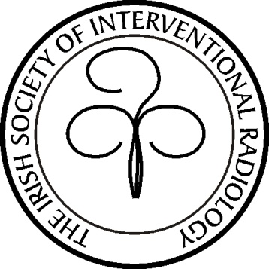

Founded in 1996

The Irish Society of Interventional Radiology

Spring Meeting 2019

Mount Juliet Estate Conference Centre, Co. Kilkenny, Ireland

Provisional Programme

Saturday May 11th 2019

14.00

Registration

Welcome
Tea/Coffee

14:30

Didactic session

Forum on IR development

The ISIR Annual General Meeting

16:45

Tea/Coffee

17:00

Guest Speaker
20.00

Pre dinner Drinks and Dinner, The Open Room

Sunday 12th of May 2019

Clinical Session

Case Presentations & Complications in Interventional Radiology I

9.00 - 11.15

Tea & Coffee

11.30 – 13.00

Case Presentations & Complications in Interventional Radiology II

Close of Meeting

https://isir.ie
Registration

Registration for the meeting will by direct email to the ISIR secretary
ibrennan@stjames.ie
Provisional closing date for registration is April 30th .

Please contact the hotel directly for accomodation bookings, quoting the ISIR rate.

Registration is free to members of the society in good standing , please see recent email correspondance from the ISIR treasurer.

CME Points

CME Points will be awarded through The Faculty of Radiologists, RCSI.

