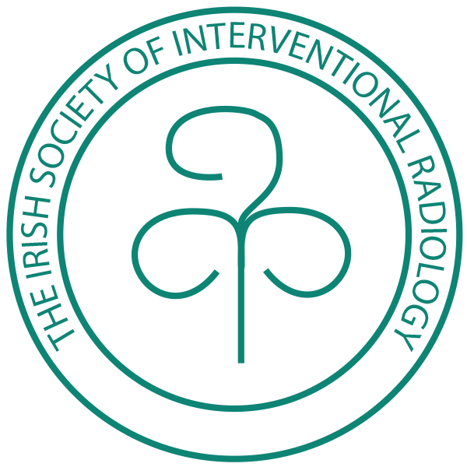

Founded in 1996

The Irish Society of Interventional Radiology

Autumn Meeting 2018

Herbert Park Hotel, Dublin, Ireland

Programme

Friday 9th of November 2018

18.00

Registration

Welcome Tea/Coffee

18.45

Keynote Lecture, Lansdowne Suite

“ @ImageGuidedSurgery – how and why to change our name “

Dr Brian Stedman, University Hospital Southampton, UK

20.00

Dinner

Lansdowne Suite,
Herbert Park Hotel

Saturday 10th of November 2018

Clinical Session

09.00 – 11.00

Herbert Suite

Case Presentations & Complications in Interventional Radiology I

11.00 - 11.15

Coffee break

11.15 – 13.00

Case Presentations & Complications in Interventional Radiology II

Close of Meeting

https://isir.ie
Registration

Registration for the meeting and/or dinner will by direct email to the ISIR secretary
ibrennan@stjames.ie
Provisional closing date for registration is October 31st .

Registration is free to members of the society in good standing , please see recent email correspondance from the ISIR treasurer.

CME Points

CME Points will be applied for through The Faculty of Radiologists, RCSI.

The ISIR Autumn Dinner

Delegates attending the meeting must also register for the dinner on Friday November 9th . Partners are welcome, however , there is an additional fee of € 40.00, payable after the event.

